**USER MANUAL**

This document provides useful tips and guidelines for running the Multicriteria Evaluation (MCE) Analysis software for Rock Aggregate Production in the UK.

The software should be run preferably on Spyder, a program under the Anaconda Package. Spyder version 3.9 is used for illustrations in this document.

To install Spyder, visit this link:<https://www.spyder-ide.org/>

Once Spyder is downloaded, launch the program:

Spyder Icon from Start menu.

The Spyder Interface has three main windows:

Editor

Help viewer

IPython console

**KEY**

Editor- The Editor section is where most of the codes writing was done. It also has docstrings and comments of codes and functions used in the software.

Help viewer – In this window, there are helpful tools including Help section, variable explorer, plots, and files. These tools are helpful in visualizing figures which have been plotted (plots), useful tips in writing codes (Help), accessing variables used in the scripts (variable explorer) and file directory (files).

IPython console – This displays some scripts results and allows writing codes also.

**LOADING THE SCRIPTS**

After launching the program, the next step is to open the source codes (scripts) needed to run the program. To do this, click on the open file icon from the toolbar or hit ctrl + O to open the MCE script files and load them. Once open file icon is clicked, a pop-up window opens. Make sure to select and open all files in the folder.

Open file icon

Pop-up box with file directory

These files should be opened to ensure that the software runs smoothly:

* suitability_analysis_model.py
* test.py
* io.py
* geometry.py

Ensure all these files are opened.

To ensure that the GUI window opens when the code is run in the subsequent steps, it is important to change the default Graphics backend option for IPython console. To do this, follow these steps:

First open the preferences dialogue box.

Click the Preferences button from the toolbar.

From the window that pops up after clicking the preferences button, click the IPython console tab to make it active. Then click Graphics tab from the vertical toolbar at the top of the window. From the Graphics backend area, click the drop-down icon and select Tkinter from the options. Accept to restart kernel if prompted and restart Spyder to apply changes effectively. See the figure below for help.

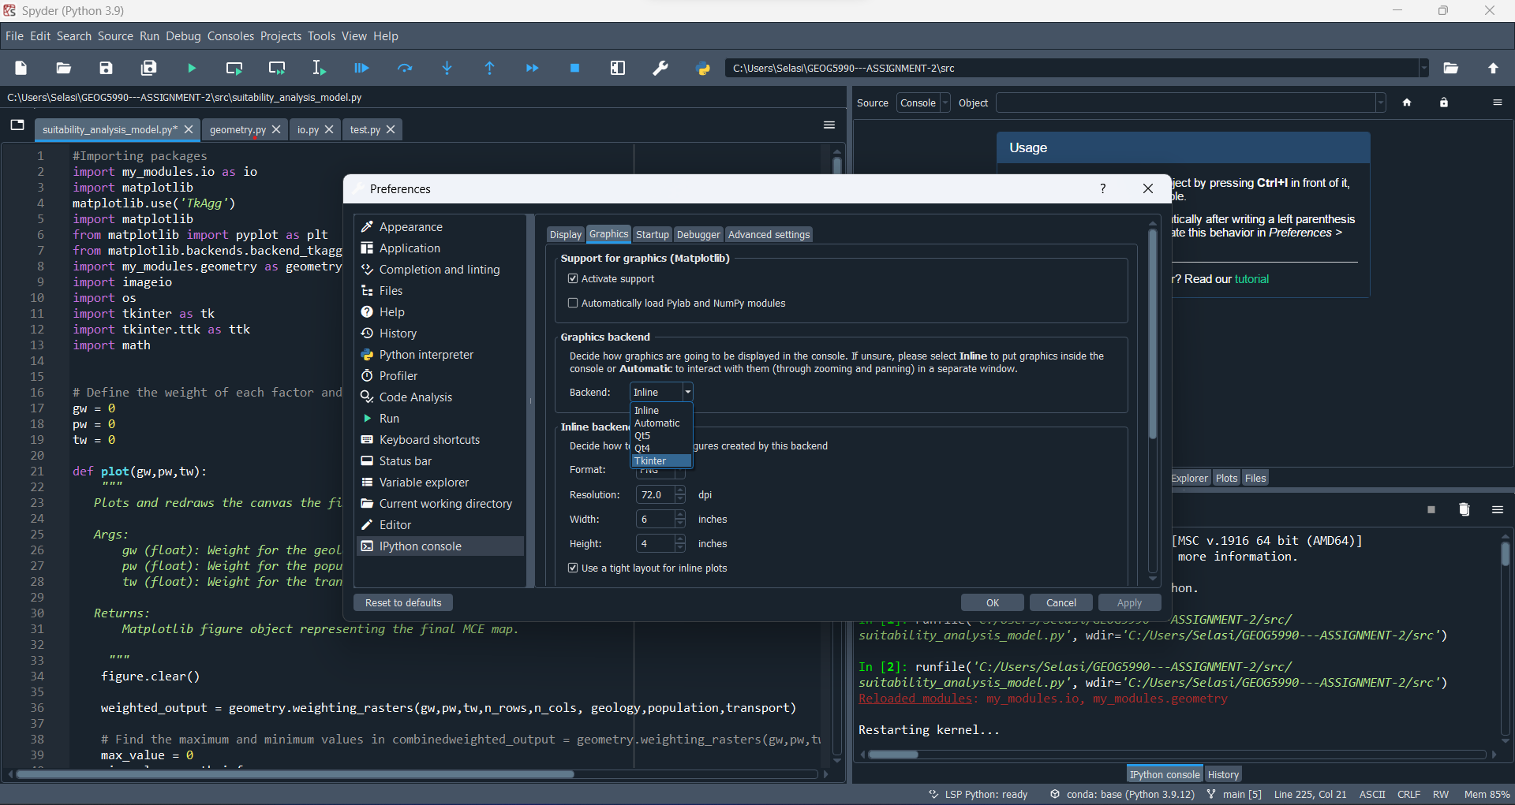

IPython console tab

Graphics tab

Click this Drop-down menu button to access Tkinter option.

Select Tkinter from the list and restart Spyder.

**Restarting Spyder**

To restart Spyder, click on file from the tabs, and click on Restart from the options.

First click File.

Then click Restart.

After Spyder successfully restarts and all files are loaded, make sure the suitability_analysis_model.py tab is active. Then click the run button to run the script and program.

Run command button.

Clicking the Run command button opens the Graphical User Interface of the program:

Plots of the 3 raster data used in the MCE.

Sliders to adjust weights of raster files

Frame that shows final output after scales are set for each raster.

Explains the output produced.

Buttons to save final MCE map output.

The program allows setting weights from 0 to 1. Set your preferred weights for all 3 raster files to create the final MCE output by moving the sliders accordingly. When the weights are set, they are multiplied by the respective raster data and summed. Then the weighted sum is further rescaled to fall within 0 – 255. The resultant map is displayed in frame 5 (middle frame in lower row).

Move these sliders to apply weights to each raster and create final map output.

Final MCE Map

Areas with higher values are most suitable for rock aggregate production. Hence, from the output, areas with the darkest shade of green are the most suitable, while those with the lightest shade are the least suitable.

The final MCE map can be saved to file as either a picture or a text file from the GUI. Click the ‘Save as Text file’ button to save the list of values of the final MCE output. Alternatively, click ‘Save as Image’ to save the final MCE output image. These files are saved in output folder within data folder.

Click this button to save the final image as a png. file

Click this button to save txt. file

After using the program safely exit by either clicking the ‘Exit’ button or closing the window:

Click this icon to close the GUI window

Alternatively, click Exit button to close the program.

Lastly, unit testing was done for the weighting_rasters function to check its accuracy. To access this test, ensure test.py tab is active and click the run command.

Click the run command button.

Results of the test are displayed here.

These are the main pointers needed to smoothly run the program. The Site Suitability Analysis program proves to be an essential tool for conducting Multicriteria Evaluation Analysis for Rock Aggregate Production.